Advanced Computer Networking and Security - 5800

Assignment -2

Packet Sniffing and Spoofing Lab

Name: SAI ROHIT JONNADA

ID :700723743

**Task 1.1 b**

Capture only the ICMP packet

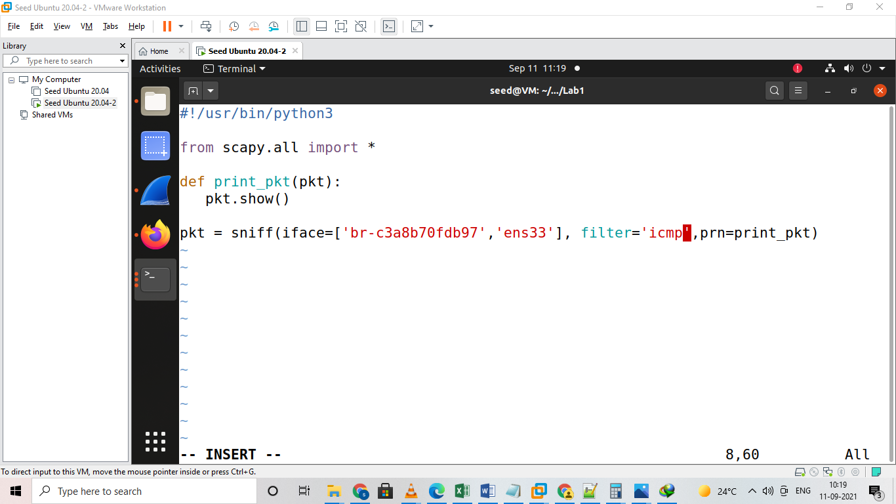

CODE FOR CAPTURING ICMP PACKETS

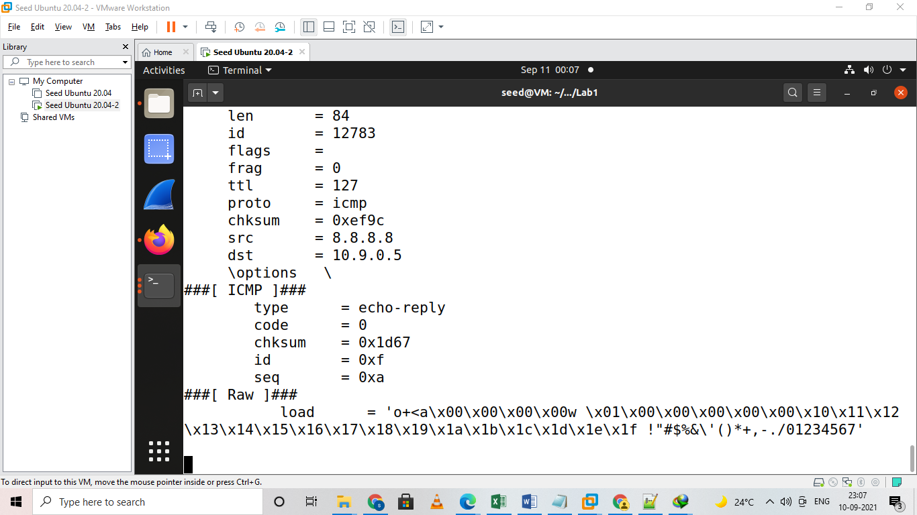

ICMP PACKETS AFTER PING 8.8.8.8

Capture any TCP packet

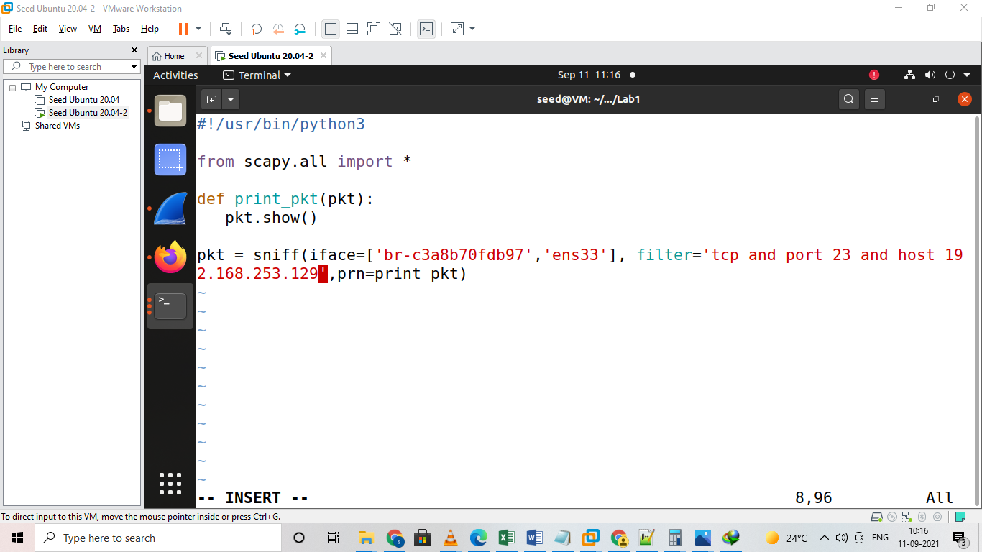

Code For Capturing any Tcp Packet from a Particular Ip

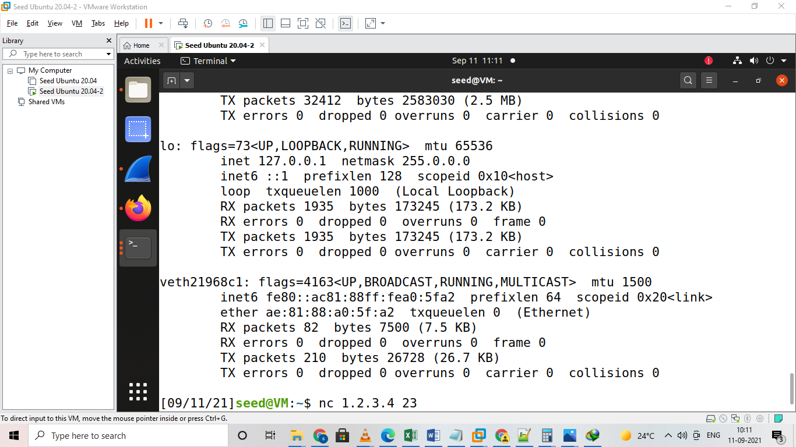

Ping 1.2.3.4 23 for Capturing tcp packets at port 23

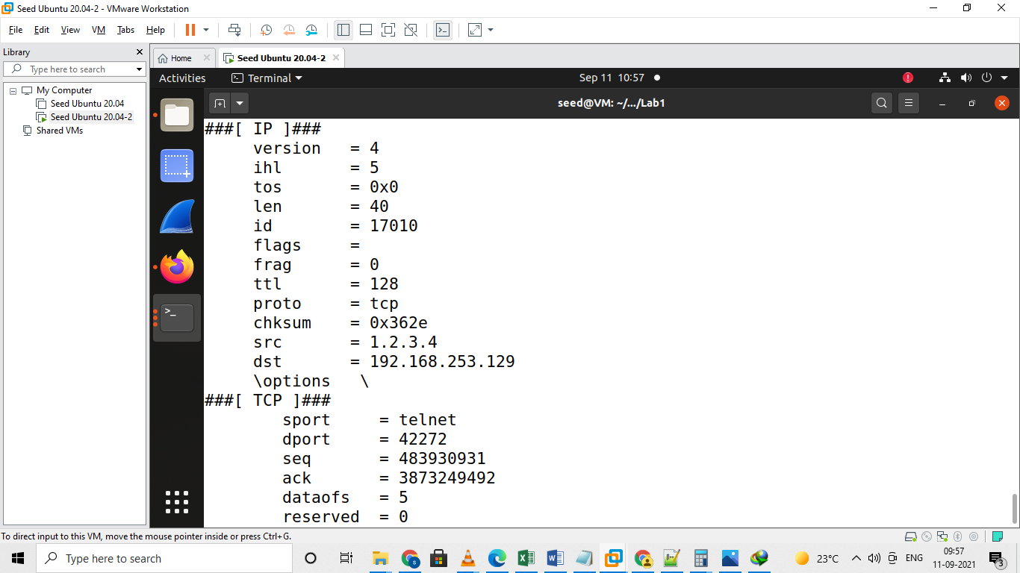

Capturing Tcp Packets of particular ip and port 23

1.1B Capture packets comes from or to go to a particular subnet

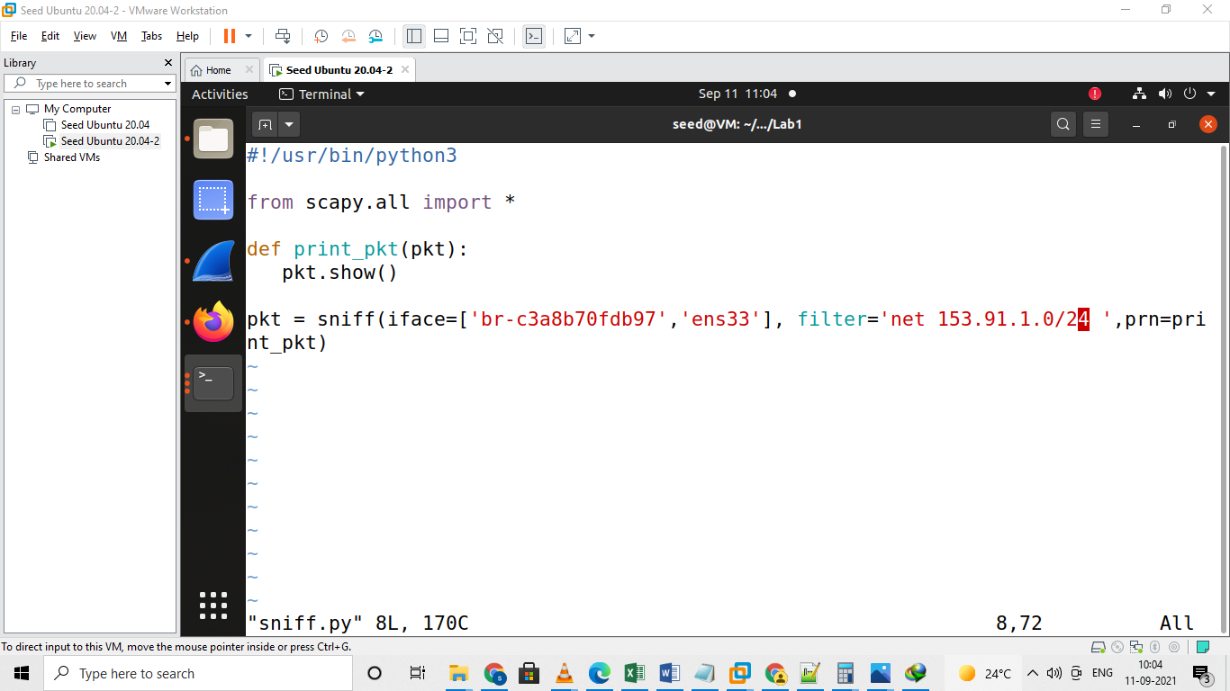

Code for Capturing Packets from Ucm

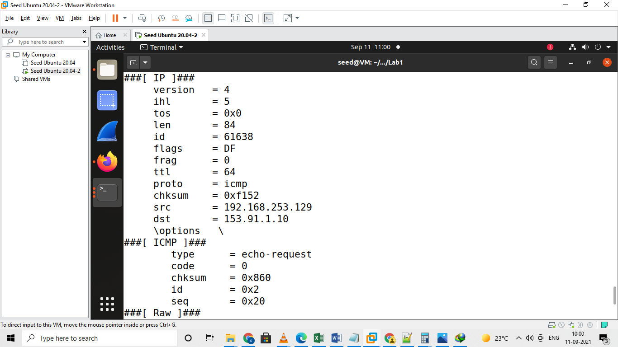

Packet tracing of UCMO

**Task 2.1 A**

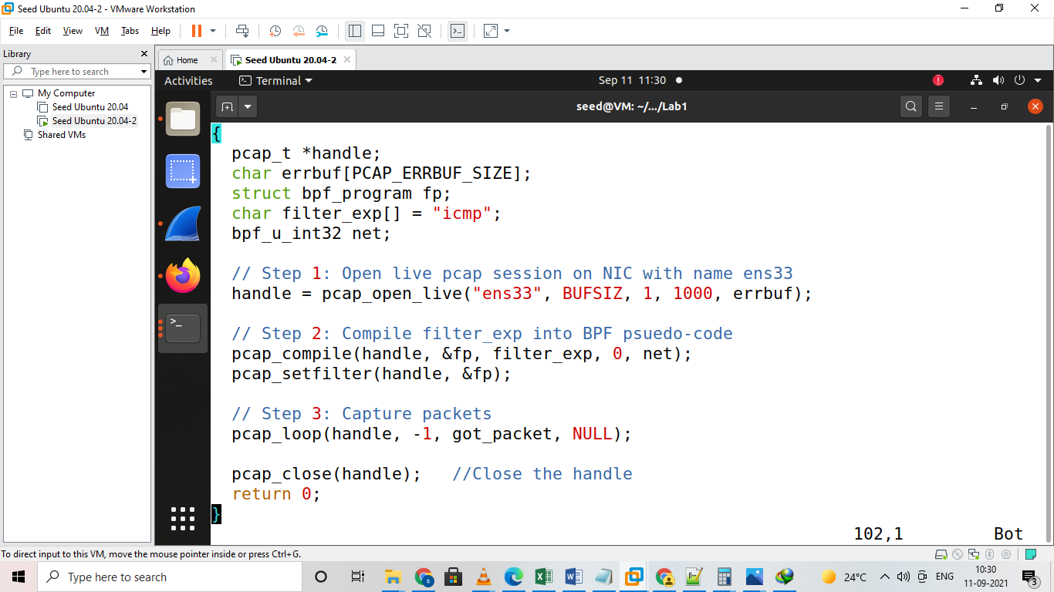

Code For Sniff Packets

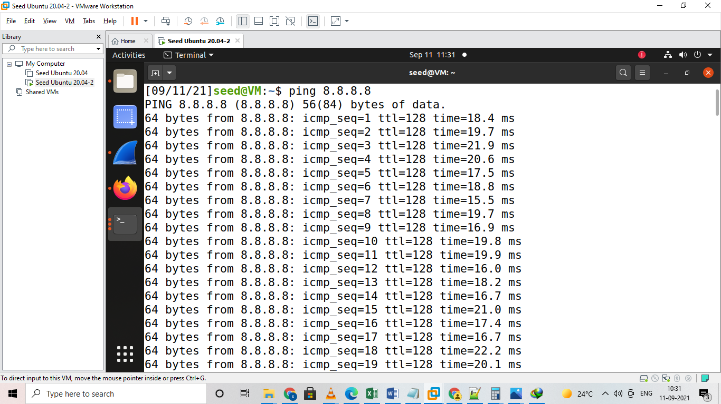

Ping 8.8.8.8 for Sniffing

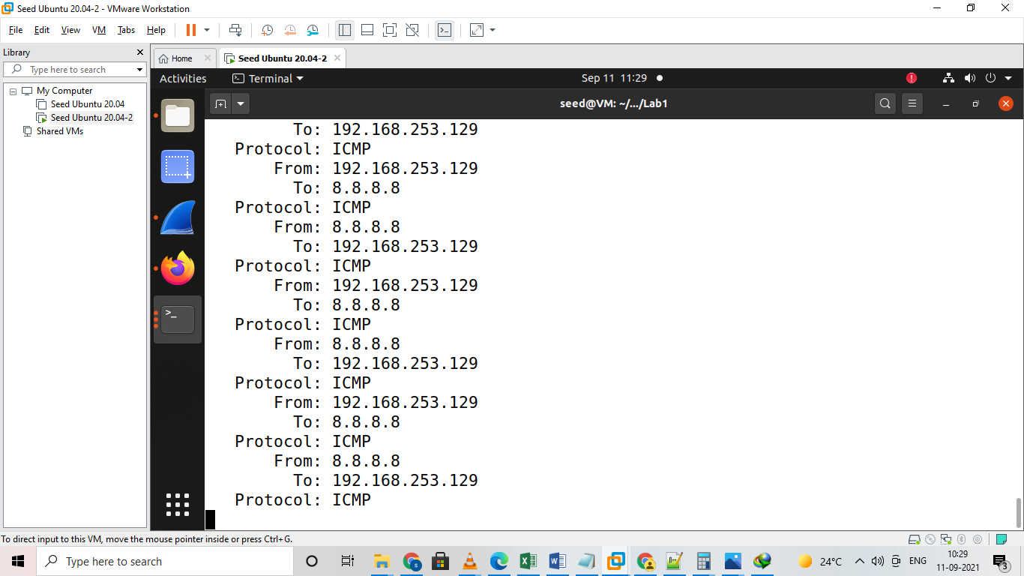

Ip and Source information for sniffing

**Task 2.2 B**

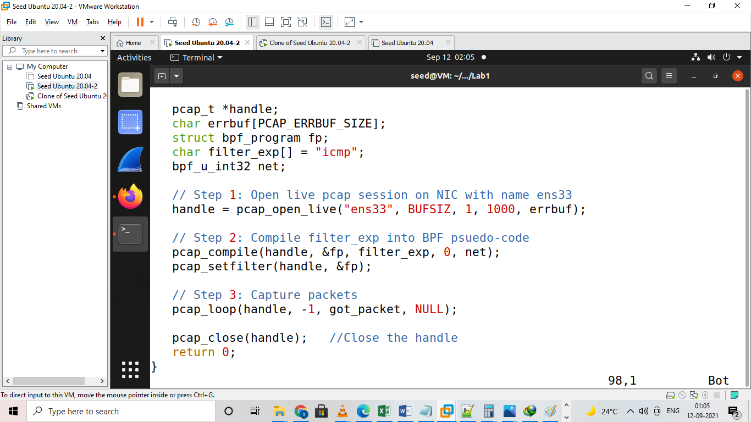

Code for Spoofing

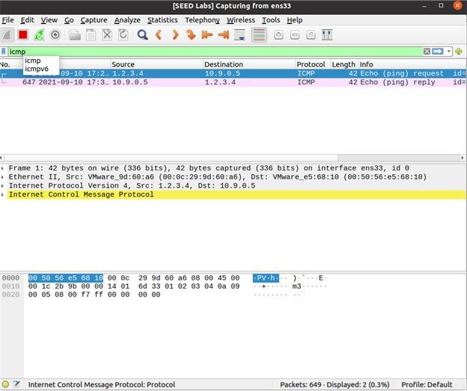

Checking whether packets are sent to Victim and replied from Wireshark

**Task 2.3B**



Code For Sniffing and Spoofing

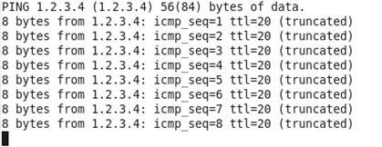

PING 1.2.3.4 FROM ANOTHER VIRTUAL HOST

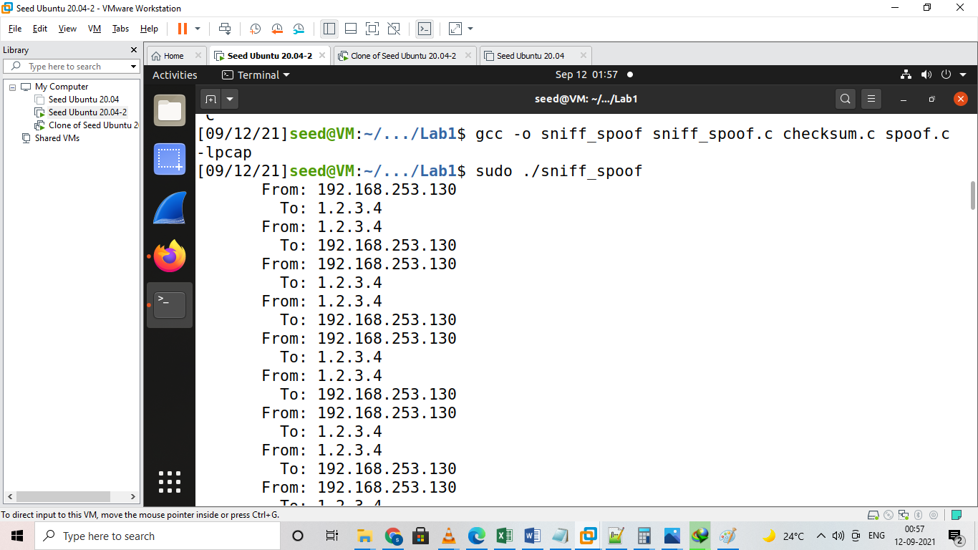

Sniffing and Spoofing